news sources

Goal
The goal is to curate a list of 5-10 high quality news sources with a focus on aggregating global news stories about current events in the domains of economics, financial markets, security and diplomacy.

For each news source it is important to provide an evaluation of the quality of the source so that it’s articles can be interpreted with the relevant context such as:
- political leaning
- ownership structure
- editorial independence
- historical outlet accuracy

Methodology
  - Sources for information on political bias and credibility:
The industry leader in media bias is the public benefit corporation Ad Fontes. They publish a media bias chart scoring outlets on political bias and news value / reliability:
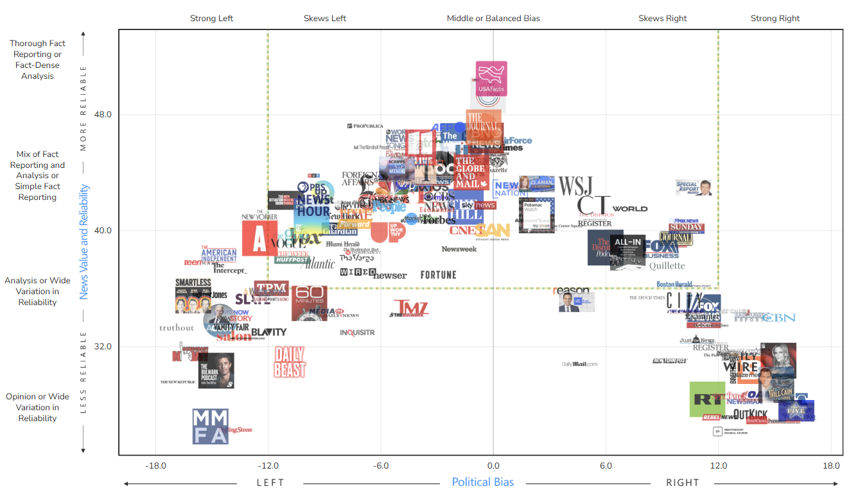

Media Bias / Fact Check (MBFC) provide similar metrics and tools on a huge range of sources and while they often described as more amateur and less academic than the larger institutions their results have been corroborated by external experts. They explain their scoring mechanisms as follows
Bias Scoring Levels
- -10 to -8.0: Extreme Left Bias
- -7.9 to -5.0: Left Bias (Far Left at -7.0+)
- -4.9 to -2.0: Left-Center Bias
- -1.9 to +1.9: Least Biased
- +2.0 to +4.9: Right-Center Bias
- +5.0 to +7.9: Right Bias (Far Right at +7.0+)
- +8.0 to +10: Extreme Right Bias
Factuality Rating Levels
- 0: Very High – Consistently factual, uses credible information, no failed fact checks.
- 0.1–1.9: High – High factual, minor sourcing issues, reasonable fact check record
- 2.0–4.4: Mostly Factual – Generally reliable but may have occasional fact-check failures, transparency, and sourcing issues.
- 4.5–6.4: Mixed – Reliability varies; multiple fact-check failures, poor sourcing, lack of transparency, one-sidedness.
- 6.5–8.4: Low – Often unreliable; frequent fact-check failures and significant issues with sourcing, transparency, propaganda, conspiracies, and pseudoscience promotion.
- 8.5–10: Very Low – Consistently unreliable, heavily biased, with intentional misinformation likely.

  - Criteria for selection
The target user for this project, a financial portfolio manager, is expected to make immensely consequential decisions based on the news media they consume. As a result of this it is enormously important that our daily summaries are reliably accurate and free from bias. While we can build software tools for verifying events, comparing evidence, analysing potential bias in articles, etc. we are still capped in the accuracy and completeness of our report by the data sources that we start with.
The primary criterion for selection is factual accuracy as any fraudulent of misleading publications could lead to disastrous consequences. Skewed political leaning and private ownership structures that lack editorial independence are a secondary concern as these can be more easily corrected for with appropriate context as long as the overall dataset is fairly balanced.
For each candidate source we initially consider its position / distribution across the Ad Fontes Media Bias Chart and the MBFC bias and factuality scores.

Candidates
  - BBC
Bias Rating: LEAST BIASED (1.5)
Factual Reporting: MOSTLY FACTUAL (2.1)
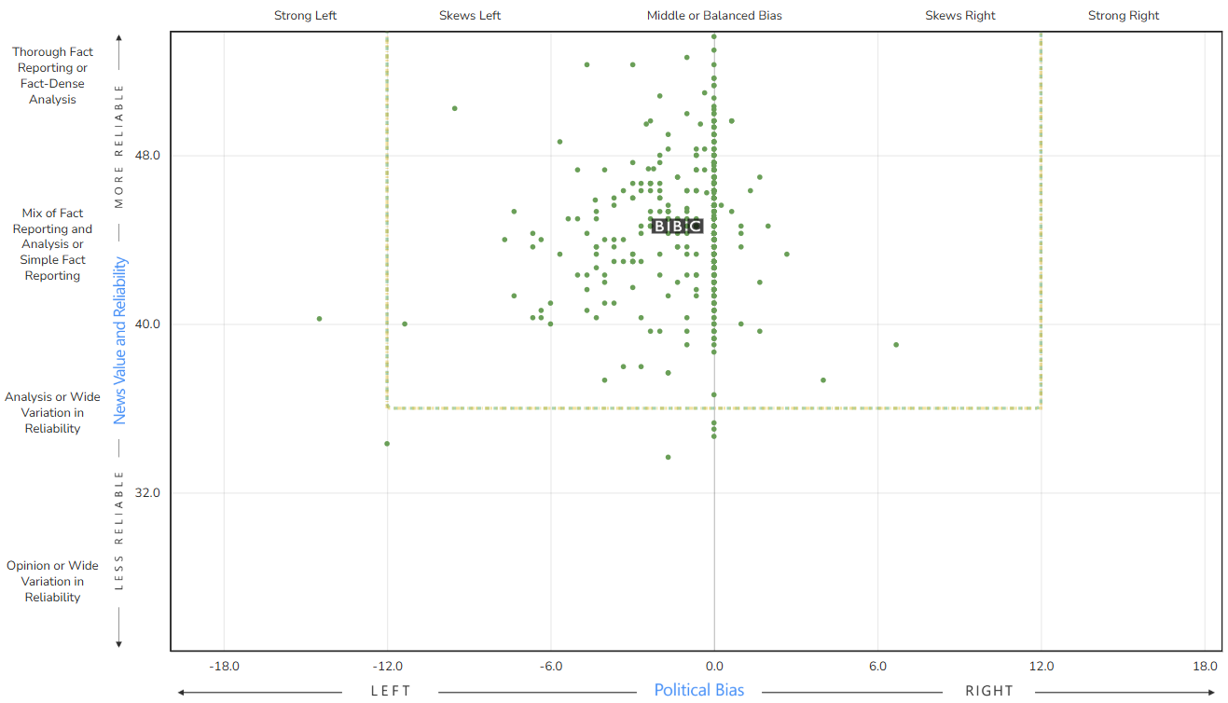
  - financial times
Bias Rating: LEAST BIASED (0.4)
Factual Reporting: HIGH (1.0)
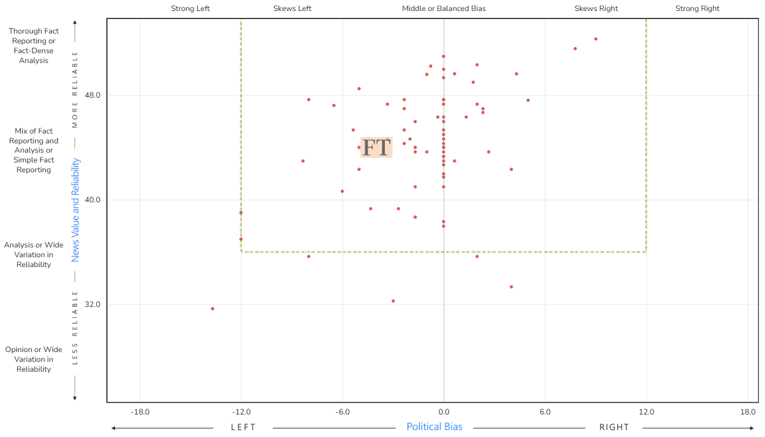
  - Reuters
Bias Rating: LEAST BIASED (-0.5)
Factual Reporting: VERY HIGH (0.0)
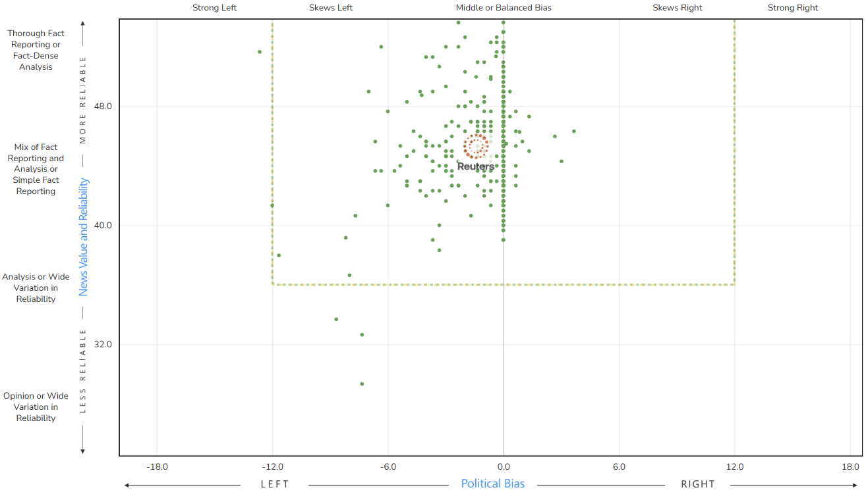
  - Wall Street Journal
Bias Rating: RIGHT-CENTER (4.2)
Factual Reporting: MOSTLY FACTUAL (2.4)
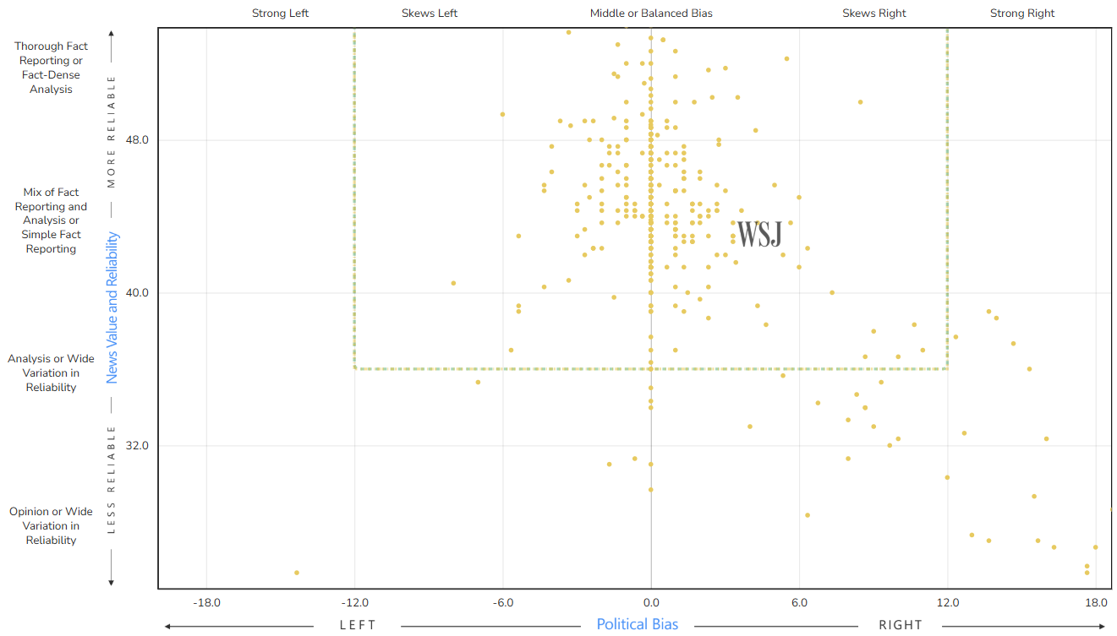
  - The New York Times
Bias Rating: LEFT-CENTER (-4.1)
Factual Reporting: HIGH (1.4)
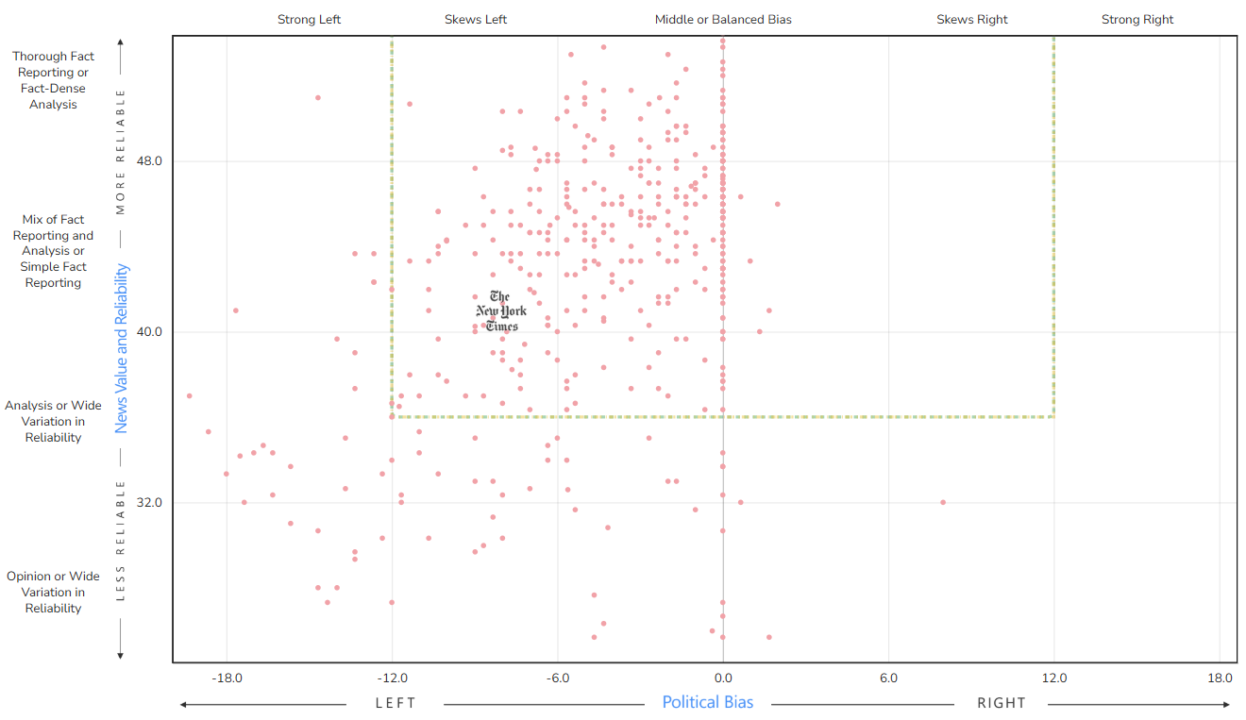
  - NPR
Bias Rating: LEFT-CENTER (-2.8)
Factual Reporting: HIGH (0.9)
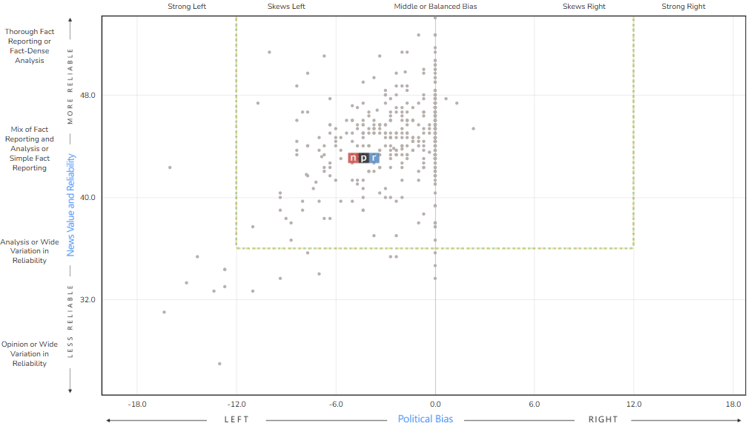
  - Washington Post
Bias Rating: LEFT-CENTER (-3.6)
Factual Reporting: MOSTLY FACTUAL (2.1)
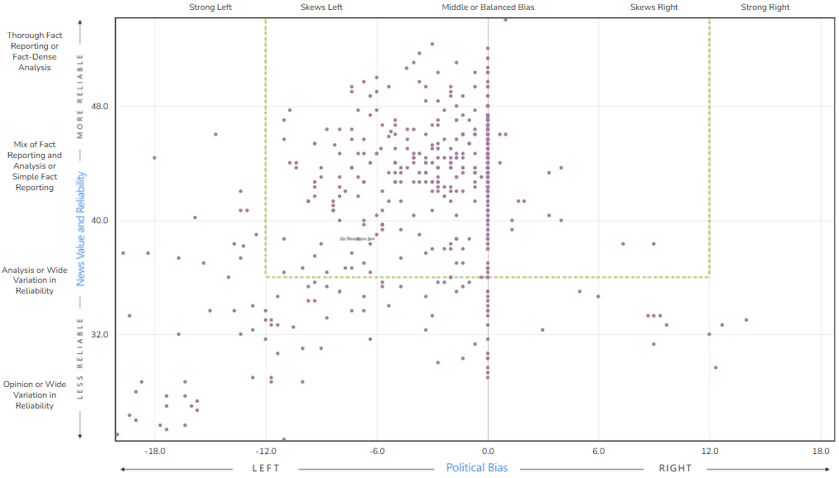
  - The Economist
Bias Rating: LEAST BIASED (0.4)
Factual Reporting: HIGH (0.8)
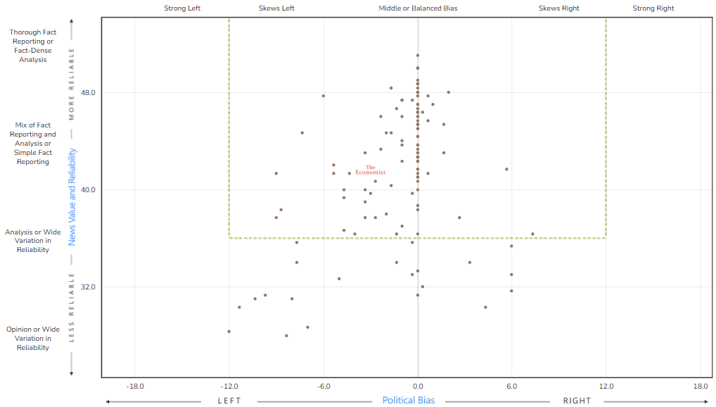
  - Bloomberg
Bias Rating: LEFT-CENTER (-2.4)
Factual Reporting: MOSTLY FACTUAL (2,2)

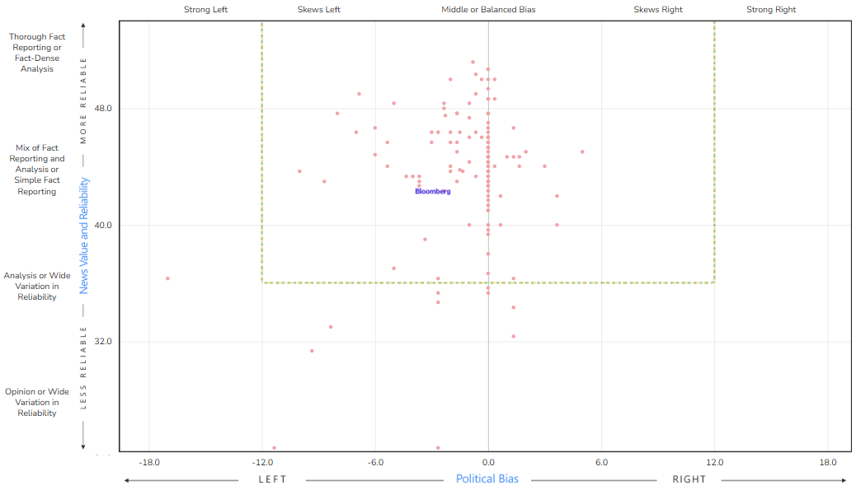
Associated Press
Bias Rating: LEFT-CENTER (-2.1)
Factual Reporting: HIGH (0.8)
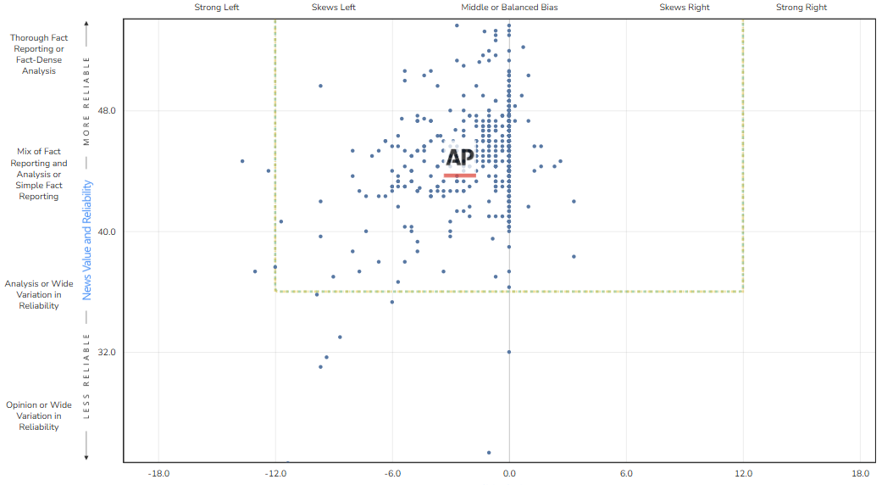

Results
  - Financial times
 | Ad Fontes | MBFC
Reliability | 44.00 | 1.0
Bias | -3.98 | 0.4
“The Financial Times is owned by The Nikkei, a Japanese news and financial information company that publishes the leading financial paper, The Nikkei. The FT generates revenue through subscriptions, a hard paywall, and advertising.”
  - BBC
 | Ad Fontes | MBFC
Reliability | 44.66 | 2.1
Bias | -1.35 | 1.5
“The BBC operates under a Royal Charter. Oversight is managed by the BBC Board, and regulatory authority rests with Ofcom. Funding is drawn primarily from the compulsory UK television license fee. The BBC is frequently accused of bias from both left and right. A 2021 Reuters Institute report found the BBC ranked #1 in trust among UK news sources.”
The BBC is our only non-privately owned source.
  - Reuters
 | Ad Fontes | MBFC
Reliability | 44.98 | 0.0
Bias | -1.40 | -0.5
“Reuters is the news and media division of Thomson Reuters, which is the world’s leading source of intelligent information for businesses and professionals and is owned by The Woodbridge Company Limited [which is] based in Toronto, Canada”
Reuters is widely regarded as one of the most highly factual sources of news media.
  - Wall Street Journal
 | Ad Fontes | MBFC
Reliability | 43.09 | 2.4
Bias | 4.39 | 4.2
“In 2007, The Bancroft family and relatives sold the Wall Street Journal to Rupert Murdoch for 5 billion dollars. Rupert Murdoch also purchased its parent company, Dow Jones & Co., through News Corporation. Subscriptions and advertising fund the Wall Street Journal.”
The Wall Street Journal is our only source that skews right wing.
  - The Economist
 | Ad Fontes | MBFC
Reliability | 41.63 | 0.8
Bias | -2.98 | 0.4
“The Economist is owned by the Economist Group, which is a British multinational media company. They are primarily owned by the Cadbury, Rothschild, Schroder, Layton, and Agnelli families. Subscriptions, advertising, and sponsored content generate revenue for the Economist. In review, The Economist takes an editorial stance of classical and economic liberalism that supports free trade, globalization, open immigration, and social liberalism”
The economist is the most focussed on financial markets of these sources.

Conclusion
Our main 5 news sources are:
- Financial Times
- BBC
- Reuters
- Wall Street Journal
- The economist
This combination gives us a good balance of political skews while maintaining a very high standard of factually accuracy and a range of different governance structures.
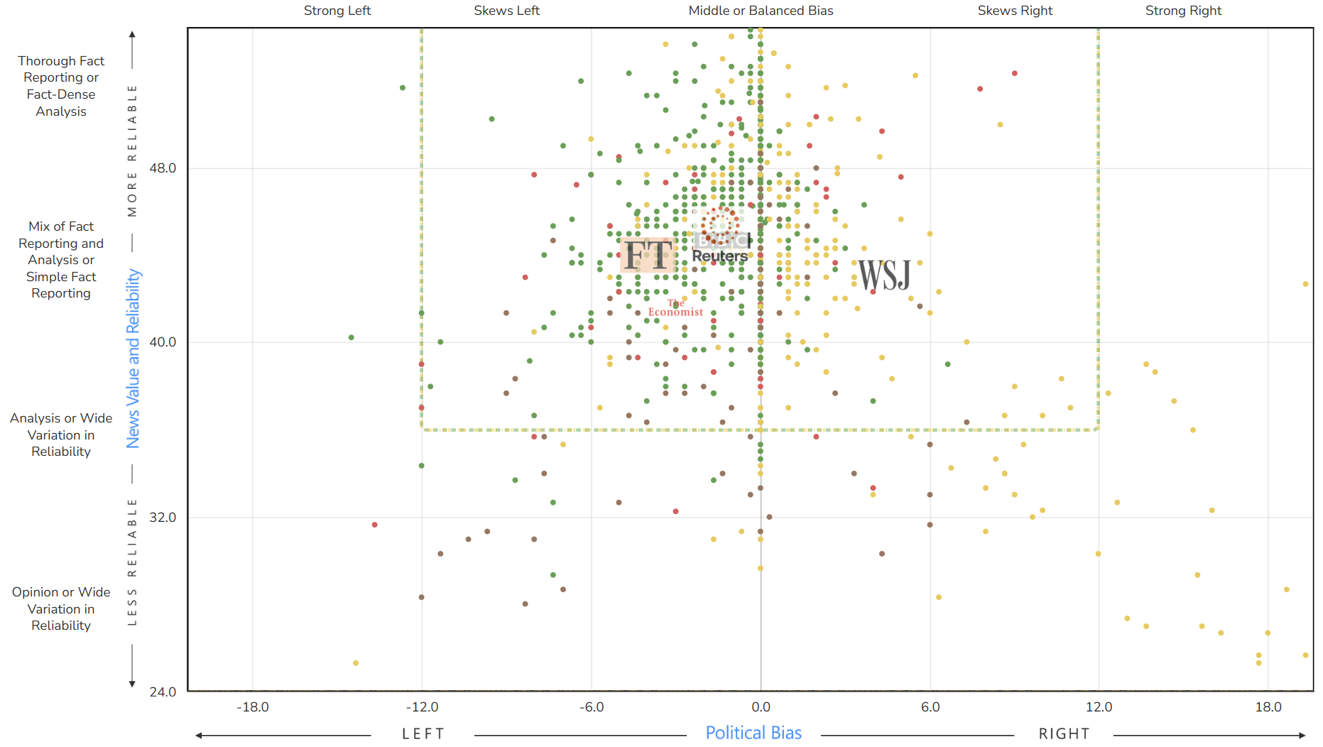
While you could argue that 4 of the 5 sources chosen are left of centre, the average skew from centre is far less than the spread / uncertainty in the measurement of these metrics. Furthermore, these metrics use a U.S.-centric political spectrum – it is not necessarily the goal to be centrist by that measure but rather to cover differing points of view appropriately.

Data Table Export
  - Unprocessed
 | Reliability |  | Bias |  | Ownership
Source | Ad Fontes | MBFC | Ad Fontes | MBFC
Financial times | 44 | 1 | -3.98 | 0.4 | “The Financial Times is owned by The Nikkei, a Japanese news and financial information company that publishes the leading financial paper, The Nikkei. The FT generates revenue through subscriptions, a hard paywall, and advertising.”
BBC | 44.66 | 2.1 | -1.35 | 1.5 | “The BBC operates under a Royal Charter. Oversight is managed by the BBC Board, and regulatory authority rests with Ofcom. Funding is drawn primarily from the compulsory UK television license fee. The BBC is frequently accused of bias from both left and right.
Reuters | 44.98 | 0 | -1.4 | -0.5 | “Reuters is the news and media division of Thomson Reuters, which is the world’s leading source of intelligent information for businesses and professionals and is owned by The Woodbridge Company Limited [which is] based in Toronto, Canada”
Wall Street Journal | 43.09 | 2.4 | 4.39 | 4.2 | “In 2007, The Bancroft family and relatives sold the Wall Street Journal to Rupert Murdoch for 5 billion dollars. Rupert Murdoch also purchased its parent company, Dow Jones & Co., through News Corporation. Subscriptions and advertising fund the Wall Street Journal.”
The Economist | 41.63 | 0.8 | -2.98 | 0.4 | “The Economist is owned by the Economist Group, which is a British multinational media company. They are primarily owned by the Cadbury, Rothschild, Schroder, Layton, and Agnelli families. Subscriptions, advertising, and sponsored content generate revenue for the Economist. In review, The Economist takes an editorial stance of classical and economic liberalism that supports free trade, globalization, open immigration, and social liberalism”

  - Scores only:
 | Reliability |  | Bias
Source | Ad Fontes | MBFC | Ad Fontes | MBFC
Financial times | 44 | 1 | -3.98 | 0.4
BBC | 44.66 | 2.1 | -1.35 | 1.5
Reuters | 44.98 | 0 | -1.4 | -0.5
Wall Street Journal | 43.09 | 2.4 | 4.39 | 4.2
The Economist | 41.63 | 0.8 | -2.98 | 0.4

